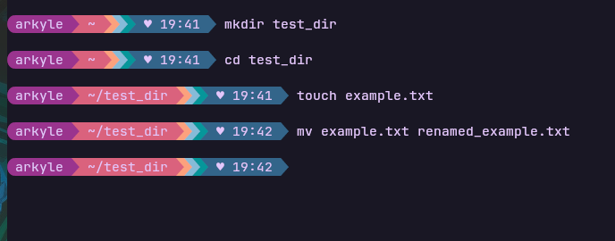
1. Created directory test_dir using mkdir command. Navigated inside test_dir to create an “example.txt” file and renamed it to “renamed_example.txt” using mv command.

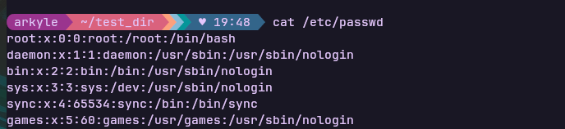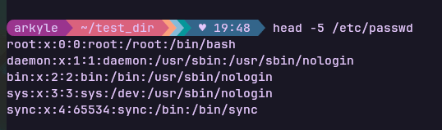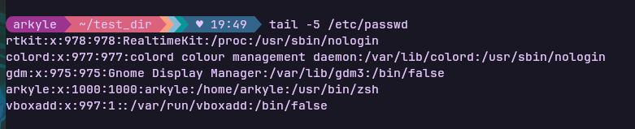
2. Used cat command to display contents of /etc/passwd and also viewed first 5 lines and last 5 lines using head and tail respectively.

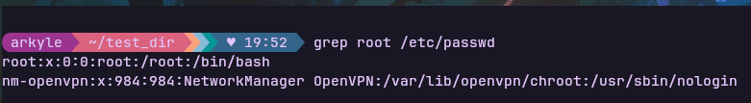3. Used grep command to find all lines containing “root” in /etc/passwd

4. Compressed the test_dir folder to test_dir.zip using the zip command. Also unzipped the test_dir.zip into a new directory unzipped_dir.

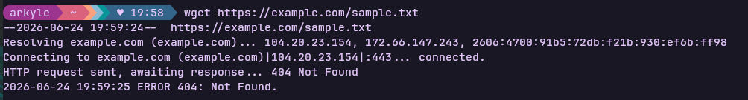5. Using wget command download a file from given URL

6. Created a file secure.txt and changed its permissions to read only for everyone.


7. Using export command, we have set a new environment variable MY_VAR with the value “Hello,Linux!”

